Day 3
Configuring Basic Networking Theory
1.Log in to your home Wi-Fi router's admin panel using its default IP address (usually 192.168.0.1 or 192.168.1.1) and take a screenshot of the login page.
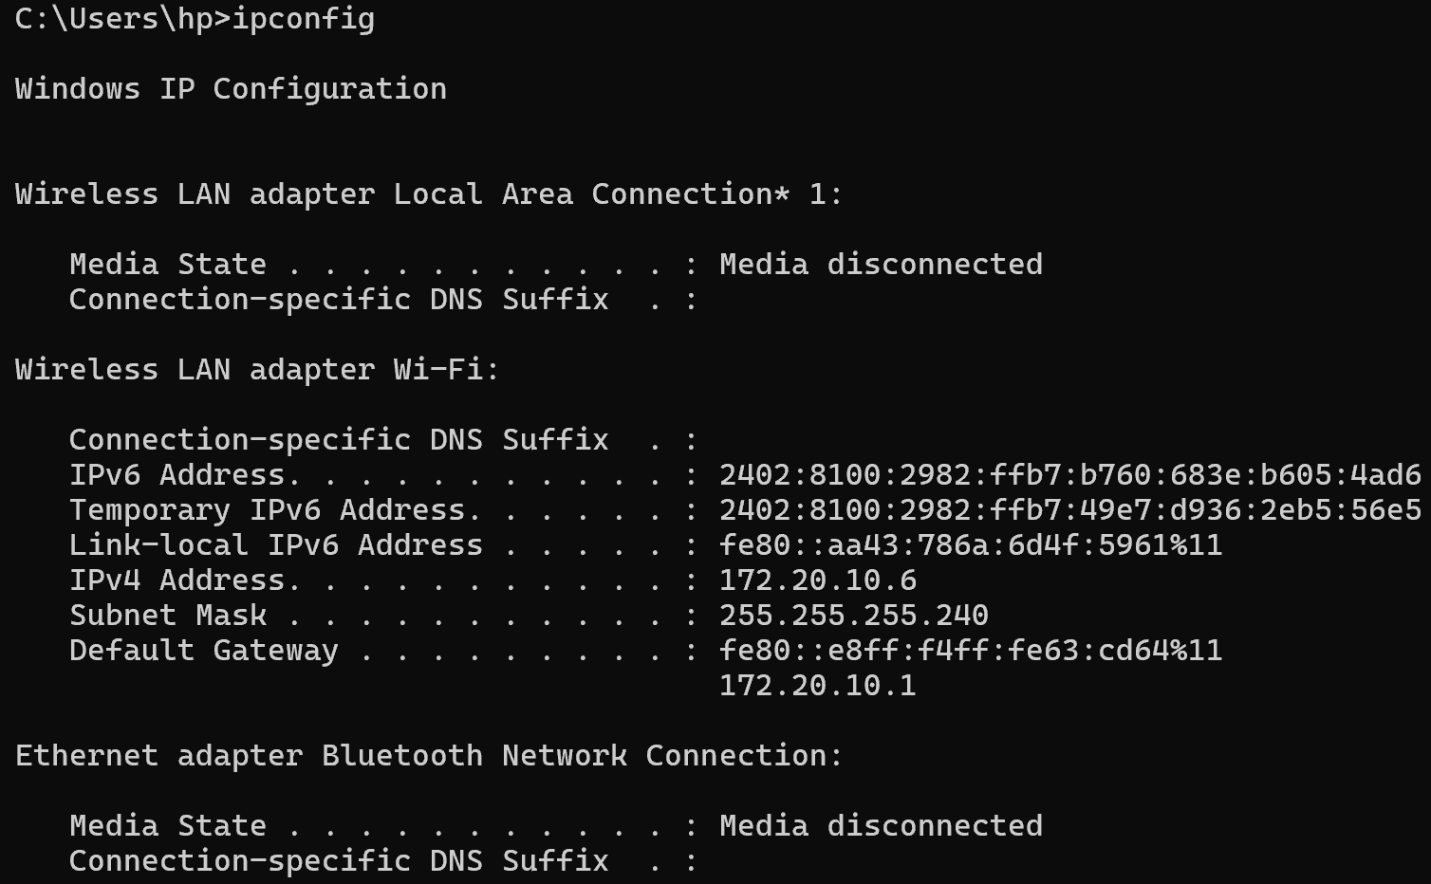
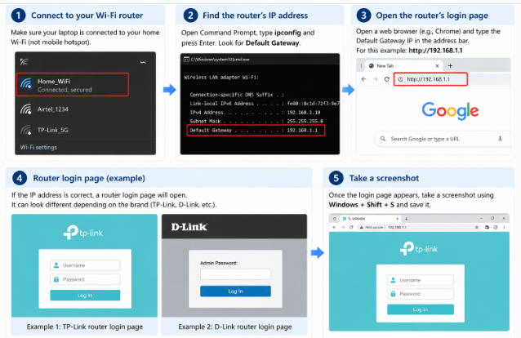

2.Find and note down the current IP address, subnet mask, and default gateway assigned to your laptop or mobile device when connected to your Wi-Fi network.
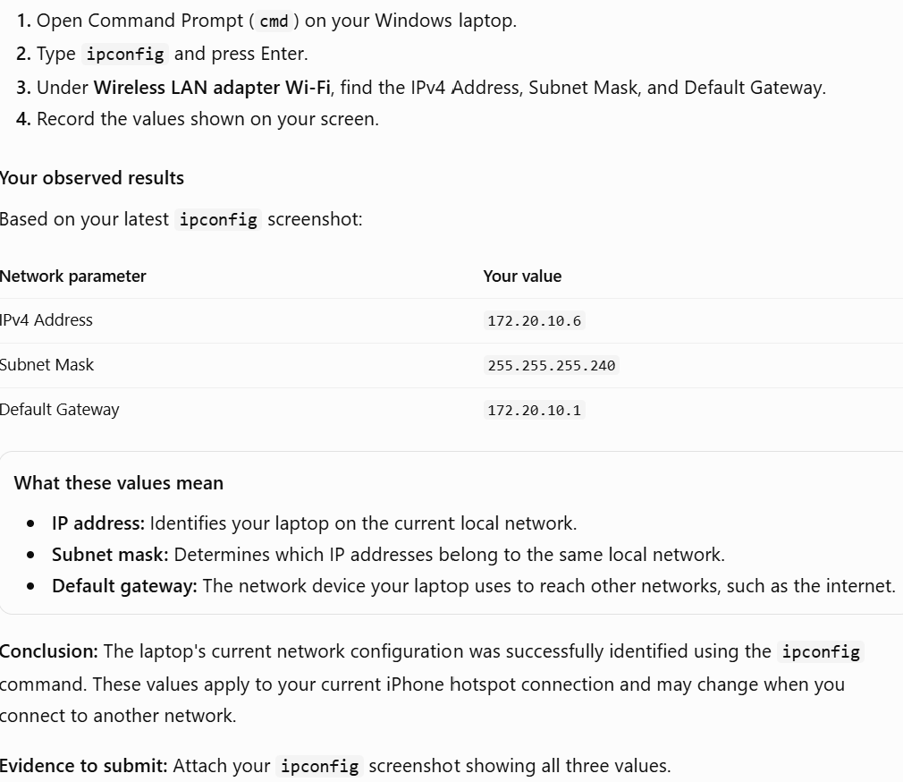
1. Subnet Mask
A subnet mask is a number that helps a computer identify which part of an IP address represents the network and which part identifies a device within that network.
Your example: 255.255.255.240
Think of it as a way to determine which devices belong to the same local network.
2. Default Gateway
A default gateway is the network device, usually a router, that forwards data from your local network to other networks, such as the internet.
Your example: 172.20.10.1

3.Change your device's IP address from 'Obtain IP automatically' (DHCP) to a static IP in the same range as your router (for example, set it to 192.168.1.50 if your router is 192.168.1.1), and test if you still have internet access.
1. To change the laptop's IP address from Obtain an IP address automatically (DHCP) to a static IP address and test the network connection.
2. What is DHCP and a Static IP?
- DHCP (Dynamic Host Configuration Protocol): Automatically assigns an IP address and other network settings to your device.
- Static IP address: An IP address that you configure manually and that remains fixed until you change it or the configuration changes.
3 Practical steps
- Step 1: Open Wi-Fi Properties
- Press Windows + R, type ncpa.cpl, and press Enter. Right-click your Wi-Fi connection and select Properties.
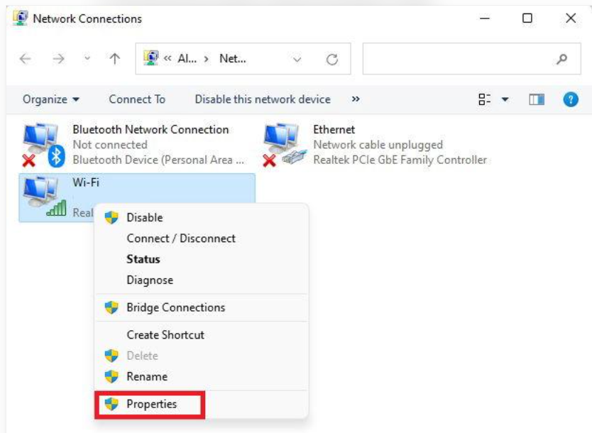
Step 2: Open IPv4 Properties
Select Internet Protocol Version 4 (TCP/IPv4) and click Properties. You will see options for automatic and manual IP configuration, just as in your screenshot.
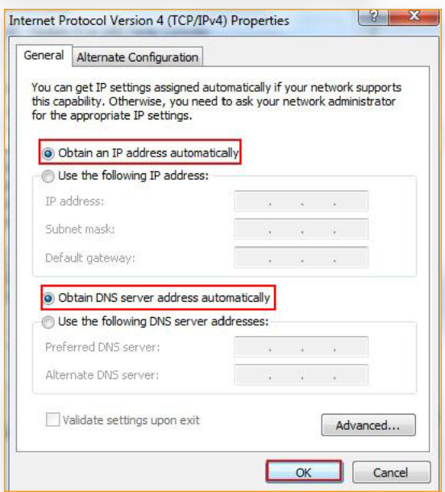
Step 3: Understand the static-IP fields
In a demonstration, the user selects Use the following IP address and enters the correct IP address, subnet mask, and default gateway for the network.
For example, a compatible network might use 192.168.1.50, subnet mask 255.255.255.0, and gateway 192.168.1.1. These are illustrative values, not settings to enter on your iPhone hotspot.
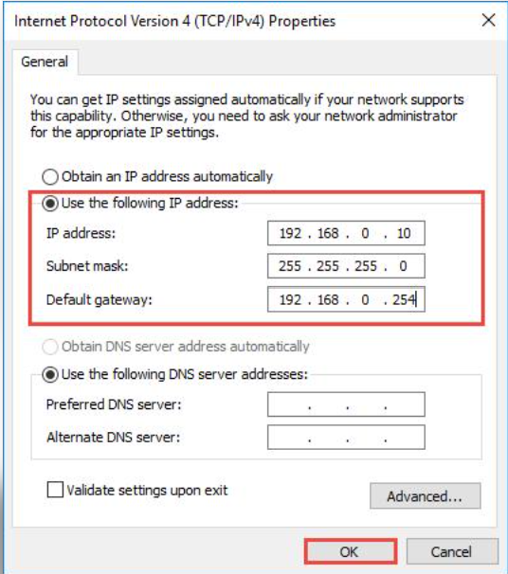
Step 4: Test connectivity
After a static IP is correctly configured, a user can run ipconfig to verify the settings and ping the router's actual gateway to test connectivity. They can also check internet access.
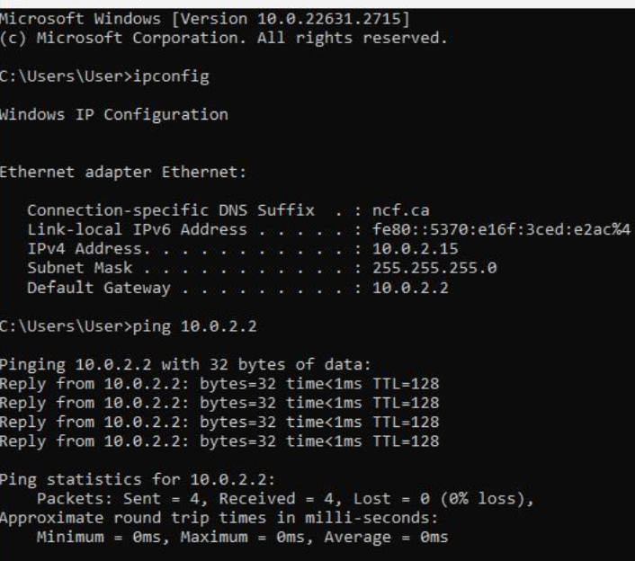

4. How to restore automatic settings
If someone performs this practical on a suitable network, they can return to IPv4 Properties and select:
- Obtain an IP address automatically
- Obtain DNS server address automatically
Then click OK to save the settings
4.In your router's admin panel, locate the section where you can view or change the DHCP range. Write down the current range, and explain in 2-3 lines what would happen if two devices are assigned the same IP address in this range
DHCP (Dynamic Host Configuration Protocol) automatically assigns IP addresses to devices connected to a network.
A DHCP range is the range of IP addresses that a router can automatically assign to devices.
For example, a router might use the following range:
- Starting IP address: 192.168.1.100
- Ending IP address: 192.168.1.200
Step 1: Open the router admin panel
Connect your laptop to the relevant Wi-Fi router and open its gateway address in a browser. Log in with authorized credentials.

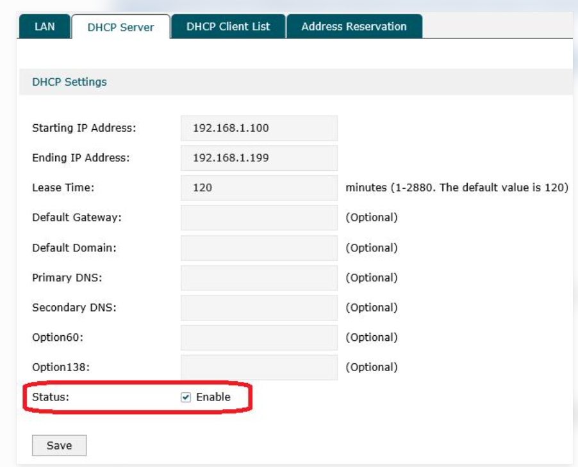
Step 2: Locate DHCP settings
Look for a section named DHCP, DHCP Server, or LAN Settings. Find the Starting IP Address and Ending IP Address fields.
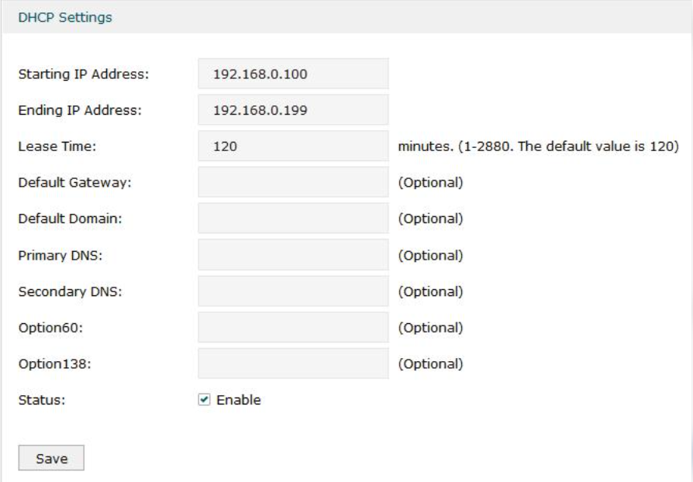
step 3: Record the range
Write down the starting and ending IP addresses displayed in your router's settings. Do not change them for this assignment.
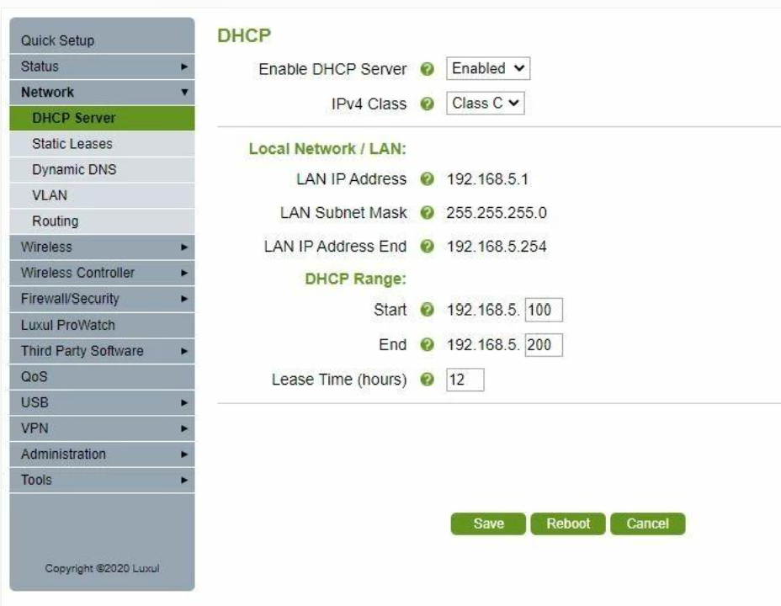

4. What happens if two devices have the same IP address?
If two devices on the same local network use the same IPv4 address, an IP address conflict can occur.
- One or both devices may lose network connectivity.
- Data may be delivered to the wrong device or connections may become unreliable.
- The conflict must be resolved by assigning unique addresses, often by allowing DHCP to assign them automatically.

